Evaluation and Optimization of a Relational Database Schema for a Student Information System (SIS)

Introduction
  - Project Overview
The core purpose of this project is to evaluate and optimize the existing relational database structure (schema) for a Student Information System (SIS). This includes a detailed analysis of the schema's design, focusing on critical factors such as quality, reliability, scalability, efficiency, effectiveness, and security. We will identify and correct structural issues, including data redundancy and normalization problems. The final result will be a complete redesign that produces an optimized database schema a robust, improved structure that guarantees better data integrity and high performance for all operations within the SIS.

  - Document Scope
This report documents the entire process we followed for the Student Information System (SIS) database optimization project. The report is organized into sections that directly match the project's work stages:
- Schema Evaluation: We start by looking closely at the original database structure. Our goal here is to find problems like having repeated data, design flaws, or tables that are not set up well (poor normalization). We judge the current schema against six important areas: quality, reliability, scalability, efficiency, effectiveness, and security.
- Optimization and Redesign: This part explains how we improved the database. It details how we applied normalization rules (up to the Third Normal Form or 3NF) to clean up the data. It also includes the plans for the new, better tables, how we added indexes to make searches faster, and the security features we implemented, like user roles and access rules.
- Implementation and Testing: Here we show how we built the improved schema in a database system (DBMS). We include the sample data we used to fill the tables and provide clear proof—SQL scripts and test screenshots—that the database works correctly. This testing covers getting data with joins, changing data, using math functions (aggregates), and checking security rules.
- Final Documentation and Results: The report wraps up by summarizing our main findings. We compare the problems we found in the original schema to the successful changes we made. We also share our thoughts on the process and how much better the system performs now. This section confirms that all final required items, including the optimized database diagram (ERD) and the SQL scripts, are complete.
1.3 Original System and Data
System Purpose
The Student Information System (SIS) is a database solution designed to manage academic records efficiently. Its primary goal is to automate the tracking of student profiles, course enrollments, daily attendance, and grading, replacing manual paperwork with a structured digital format.
Source and Technical Setup
The project files were sourced from a GitHub repository as a ZIP file containing two main scripts: SIS_TABLES.sql (table structures) and SIS_QUERY.sql (data queries).
To set up the system locally, I followed these steps:
- Database Creation: Created a new database named studentinformationsystem using XAMPP.
- File Placement: Moved the sis_table.sql file into the xampp/mysql/bin directory.
- Data Import: Used the Command Prompt to import the tables into the new database with this syntax: mysql -u root -p studentinformationsystem < sis_table.sql
Table Structure and Relationships
The database is organized into five core tables, each serving a specific role in the school's ecosystem. These tables use Primary Keys for identification and Foreign Keys to ensure the data stays connected and accurate.
- Students: This is the master list of all learners. It stores unique Student IDs, names, email addresses, and contact numbers.
- Courses: This table lists all available subjects, their credit values, and the departments they belong to.
- Enrollments: This acts as a bridge between students and courses. It records which student is taking which subject and the date they joined.
- Grades: This table tracks academic performance. It links a specific student to a course and records their assignment names and numerical scores.
- Attendance: This is used for daily monitoring. It logs whether a student was present or absent for a specific course on a specific date.

Original Schema Analysis

2.1 Initial Entity-Relationship Diagram (ERD)

The ERD serves as the visual blueprint of our database. It shows how different entities, like students and courses, interact through defined relationships.
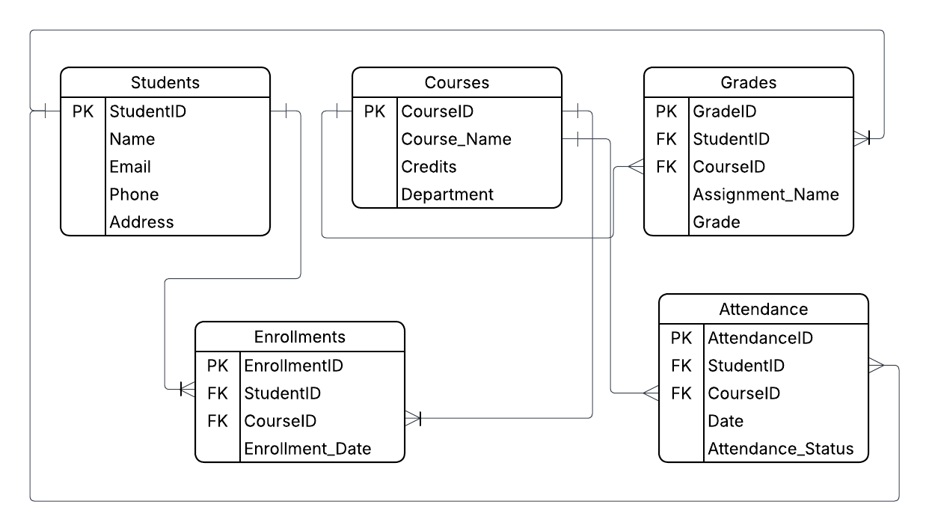

Table Explanations

Based on the visual representation, the system is organized into five core tables:
- Students: Acts as the primary directory for all learners, storing unique IDs, names, and contact details.
- Courses: Contains the list of available subjects, their credit values, and the departments managing them.
- Enrollments: A junction table that links a student to a specific course and records their enrollment date.
- Grades: Tracks academic results by connecting a student to a course and recording assignment names and scores.
- Attendance: Monitors daily presence by linking students and courses to a specific date and status.

Relationships and Cardinality

In this system, cardinality defines how many records in one table relate to records in another. The relationships are structured as follows:
- Students to Enrollments (One-to-Many): One student can have multiple enrollment records if they take several classes. However, each specific enrollment entry belongs to only one student.
- Courses to Enrollments (One-to-Many): One course can have many students enrolled in it. Conversely, each enrollment record identifies one specific course being taken.
- Students to Grades (One-to-Many): A single student can receive many grades across different assignments and subjects. Each grade record is linked back to exactly one student.
- Courses to Grades (One-to-Many): One course can generate many grade entries for the various students and tasks within that subject.
- Students to Attendance (One-to-Many): One student will have many attendance logs (one for every day or class they attend). Each log entry corresponds to one specific student.
- Courses to Attendance (One-to-Many): A single course tracks attendance for many dates and many students. Each attendance record is tied to one specific course.

Understanding the Relationships

The lines connecting these tables represent how the data is related:
- Primary Keys (PK): These are unique identifiers, such as StudentID or CourseID, that ensure every record is distinct.
- Foreign Keys (FK): These are copies of Primary Keys placed in other tables (like StudentID inside the Grades table) to create a link between them.
- Data Integrity: By using these links, the system ensures that a grade cannot be recorded for a student who does not exist in the primary Students table.

2.2 Identification of Design Issues (Schema Flaws)

Normalization Issues/Redundancy

After investigating the table structures and the data being entered, here are the identified issues:

1. Mixed Data in the Address Field (The "Clutter" Flaw)
- The Issue: In the Students table, the Address column stores the entire address (like "123 Main St") in one single box.
- Normalization Problem: This violates First Normal Form (1NF). 1NF requires that every column should hold the smallest possible piece of data.
- Why it matters: Because the street and house number are combined, you cannot easily search for all students living on a specific street or in a specific city. The data is "cluttered" together.

2. Redundant Relationships (The "Double Entry" Flaw)
- The Issue: The Grades and Attendance tables both use Student_ID and Course_ID to link a student to a class. However, this same link already exists in the Enrollments table.
- Normalization Problem: This creates Redundancy. You are recording the fact that "John is in Math" in three different places (Enrollments, Grades, and Attendance).
- Why it matters: If you delete an enrollment but forget to delete the grade, you will have a grade for a student who isn't even in the class. It makes the data harder to keep accurate.

3. Data Type Mismatch (The "Rounding" Flaw)
- The Issue: In the table setup, the Grade column is set as an INT (Integer), which only allows whole numbers. However, the data you are inserting uses decimals (like 85.00 and 78.00).
- The Problem: While this isn't a normalization rule violation, it is a data integrity flaw.
- Why it matters: If a teacher enters a grade of 85.5, the database will automatically round it or cut off the .5 because it was told to only expect whole numbers. This results in incorrect student records.

4. Limited Attendance Status (The "Consistency" Flaw)
- The Issue: The Attendance_Status is a simple text field (VARCHAR).
- The Problem: There is no rule stopping someone from typing "P," "Pres," or "Present" for the same thing.
- Why it matters: This makes it difficult to count how many days a student was present. If different people type the status differently, the computer won't realize they mean the same thing. It should be restricted to a specific list of choices.

Inefficient Relationships/Key Design

This section looks at how the tables are connected and whether the IDs (keys) are doing their job efficiently.
- By passing the "Enrollment" Rule: In a school, you shouldn't have a grade if you aren't enrolled in the class. Currently, the Grades and Attendance tables link directly to Student_ID and Course_ID. This is inefficient because the database has to look at two separate tables to verify a student. It is better to link these tables to a single Enrollment_ID. This ensures that a grade can only exist if a matching enrollment record exists first.
- Missing Search Indexes: Your tables use "Primary Keys" (the IDs), which is great for the computer. However, as the school grows, you will likely search for students by Name or Email. Right now, there are no "Indexes" on those columns. Without an index, the computer has to read every single row one by one to find a person, which becomes very slow as the list gets longer.

Data Integrity Concerns

Data integrity is about making sure the information stays accurate and "clean." There are a few spots where the current design could allow "dirty" or "broken" data:
- The "Empty Box" Problem (Missing NOT NULL): In your SQL code, columns like Name, Email, and Course_Name do not have the NOT NULL command. This means the database would allow you to save a student record with no name or a course with no title. This would make your reports useless because you would have "ghost" records with missing information.
- Grade Accuracy (Whole Numbers vs. Decimals): As mentioned before, the Grade column is set to INT. If a student earns an 88.5, the database will force it to be 88 or 89. This is a data integrity issue because the data stored in the system no longer matches the actual performance of the student.
- Invalid Attendance Status: Because the Attendance_Status is just a text field, there is no "guardrail." Someone could accidentally type "Pizza" instead of "Present." Without a rule (called a "Check Constraint"), the database will accept any word, which ruins your ability to track attendance accurately.

Schema Quality Evaluation

3.1 Quality and Reliability

This section looks at whether the data stays accurate and "true" over time.
Feature | Evidence | Investigator's Finding
Data Type Match | Grade INT but data is 85.00 | Fail. The system asks for whole numbers but tries to save decimals. This leads to rounded or cut-off grades.
Mandatory Data | Missing NOT NULL on names and emails. | Risk. The system allows "empty" students to be created without names or contact info, making the records useless.
Input Rules | Attendance_Status is a free-text VARCHAR(10). | Weak. There is no guardrail to stop someone from typing "Late," "L," or "Late!" for the same thing.

3.2 Scalability

How well will this handle 10,000+ students?
- Positive Evidence: The use of INT PRIMARY KEY for all tables is a smart move. Integers are small and very fast for a computer to process. This allows the system to grow significantly without the database becoming too heavy.
- The Problem: The Address VARCHAR(100) in the Students table is too short. If the school starts accepting international students with long addresses, the data will be cut off, and you won't be able to save the full record.

3.3 Efficiency

This section checks if the system is fast or if it will "lag" during busy times (like enrollment week).
Area | Evidence | Investigator’s Finding
Search Speed | No INDEX on Name or Course_Name. | Slow. To find one student by name, the computer must scan the entire list from top to bottom. This will cause lag as the school grows.
Data Connection | Grades links to Student_ID AND Course_ID. | Redundant. It takes more work for the database to check two links instead of one link to an Enrollment_ID.

3.4 Effectiveness

Does this actually work like a real school?
- Missing Timeframe: The schema is missing a "Semester" or "School Year" column in the Enrollments and Grades tables.
- The Issue: If a student takes "Calculus" in 2022 and fails, then takes it again in 2023 and passes, the current design can't easily tell the difference. It treats every course as a one-time thing, which doesn't reflect how real schools work.
- Address Clutter: As noted before, combining the whole address into one box makes it impossible for the school to send mailers filtered by "City" or "Zip Code."

3.5 Security (Initial State)
- Finding: The current SQL file only focuses on "what" to store, not "who" can see it.
- The Problem: There are no user roles (like "Teacher," "Registrar," or "Student"). In its current state, anyone with access to the database could change their own grades or delete attendance records. There are no "access controls" defined in this basic structure yet.

Optimization and Redesign

4.1 Normalization Process

In this section, we will walk through the process of normalizing the Student Information System (SIS). Normalization helps in organizing data efficiently, reducing redundancy, and ensuring that the database is structured in a way that minimizes errors and inconsistencies. We will break down the system step-by-step, applying the rules of 1NF, 2NF, and 3NF to transform your original schema into its most efficient form.
  - First Normal Form (1NF)

To reach 1NF, we must ensure all attributes are atomic (indivisible) and there are no repeating groups. All relational tables must satisfy 1NF requirements.
- STUDENTS
Student_ID | First_Name | Last_Name | Email | Phone | Street | City

Zip_Code

1NF (Student_ID → First_Name, Last_Name, Email, Phone, Street, City, Zip_Code)
- Partial Dependency: None
- Transitive Dependency: None

- COURSES
Course_ID | Course_Name | Credits | Department

1NF (Course_ID → Course_Name, Credits, Department)
- Partial Dependency: None
- Transitive Dependency: None

- ENROLLMENTS
Enrollment_ID | Student_ID | Course_ID | Enrollment_Date

1NF (Enrollment_ID → Student_ID, Course_ID, Enrollment_Date)
- Partial Dependency: None
- Transitive Dependency: None

- GRADES
Grade_ID | Student_ID | Course_ID | Assignment_Name | Grade

1NF (Grade_ID → Student_ID, Course_ID, Assignment_Name, Grade)
- Partial Dependency: Yes (Student_ID and Course_ID together are a partial dependency as they relate to an Enrollment)
- Transitive Dependency: None

- ATTENDANCE
Attendance_ID | Student_ID | Course_ID | Date | Attendance_Status

1NF (Attendance_ID → Student_ID, Course_ID, Date, Attendance_Status)
- Partial Dependency: Yes
- Transitive Dependency: None

B. Second Normal Form (2NF)

To reach 2NF, we eliminate partial dependencies by making new tables and reassigning dependent attributes.
    - STUDENTS
Student_ID | First_Name | Last_Name | Email | Phone | Street | City

Zip_Code

2NF (Student_ID → First_Name, Last_Name, Email, Phone, Street, City, Zip_Code)

    - COURSES
Course_ID | Course_Name | Credits | Department

2NF (Course_ID → Course_Name, Credits, Department)

    - ENROLLMENTS
Enrollment_ID | Student_ID | Course_ID | Enrollment_Date

2NF (Enrollment_ID → Student_ID, Course_ID, Enrollment_Date)

    - GRADES (Optimized)
Grade_ID | Enrollment_ID | Assignment_Name | Grade

2NF (Grade_ID → Enrollment_ID, Assignment_Name, Grade)
- Removing Student_ID and Course_ID here eliminates partial dependency.

    - ATTENDANCE (Optimized)
Attendance_ID | Enrollment_ID | Date | Attendance_Status

2NF (Attendance_ID → Enrollment_ID, Date, Attendance_Status)

C. Third Normal Form (3NF)

To reach 3NF, we eliminate transitive dependencies (where a non-key attribute determines another non-key attribute).
- DEPARTMENTS (New Table)
Dept_ID | Dept_Name

3NF (Dept_ID → Dept_Name)

- COURSES (Refined)
Course_ID | Course_Name | Credits | Dept_ID

3NF (Course_ID → Course_Name, Credits, Dept_ID)
- Moving Department to a separate table removes the transitive dependency from the Course table.

- STUDENTS
Student_ID | First_Name | Last_Name | Email | Phone | Street | City

Zip_Code

3NF (Student_ID → First_Name, Last_Name, Email, Phone, Street, City, Zip_Code)

- ENROLLMENTS
Enrollment_ID | Student_ID | Course_ID | Enrollment_Date

3NF (Enrollment_ID → Student_ID, Course_ID, Enrollment_Date)

- GRADES
Grade_ID | Enrollment_ID | Assignment_Name | Grade

3NF (Grade_ID → Enrollment_ID, Assignment_Name, Grade)

- ATTENDANCE
Attendance_ID | Enrollment_ID | Date | Attendance_Status

3NF (Attendance_ID → Enrollment_ID, Date, Attendance_Status)

Summary of Normalization Rules Applied
- First Normal Form (1NF): All attributes in each table are atomic (split addresses and names). There are no repeating groups, and all attributes depend on the primary key.
- Second Normal Form (2NF): All tables passed 1NF. We eliminated partial dependencies in the Grades and Attendance tables by linking them solely to the Enrollment_ID.
- Third Normal Form (3NF): All tables passed 2NF. We removed transitive dependencies by creating a dedicated Departments table, ensuring no non-key attribute determines another.

4.2 Data Integrity and Performance Improvements

Optimized Table Structures

To fix the flaws found in the original design, several changes were made to the tables to make the data more reliable and accurate:
- Atomic Fields: In the Students table, I split the "Name" and "Address" columns. By having separate columns for First_Name, Last_Name, Street, City, and Zip_Code, we ensure the data is in its smallest form. This makes searching and sorting much easier.
- Decimal Precision: I changed the Grade data type from INT to DECIMAL(5,2). This prevents the "Rounding Flaw" where the database would cut off points (like turning an 85.5 into an 85).
- Mandatory Rules: I added NOT NULL constraints to critical fields like names and emails. This prevents "ghost records" where a student or course might be created with no name.
- Status Constraints: In the Attendance table, I added a CHECK constraint. This forces the system to only accept 'Present', 'Absent', or 'Late', which keeps the data clean and consistent.

Indexing Strategy

When a database gets large, searching through it can become slow. To prevent this, I added specific "Shortcuts" called Indexes:
- Foreign Key Indexing: I placed indexes on Student_ID, Course_ID, and Enrollment_ID. Since these columns are used constantly to link tables together during a search (Joins), indexing them makes the connection happen almost instantly.
- Search Column Indexing: I added an index to the Last_Name and First_Name columns in the Students table. Usually, school staff search for students by name rather than ID number. An index allows the computer to find the name without reading every single row in the database.
- Unique Email Index: The Email column is indexed and marked as UNIQUE. This serves two purposes: it makes looking up a student by email fast, and it stops two students from accidentally using the same email address.

Query Optimization

To keep the system running efficiently and to make it easier for the people using it, I have planned the following optimizations:
- Student Progress View: Instead of writing a long, complex command every time a teacher wants to see a student's grades and attendance, we can create a "View." This is a saved "virtual table" that pre-calculates the joins between Students, Enrollments, and Grades.
- Automated Enrollment Procedure: I suggest using a Stored Procedure for the enrollment process. This single command would check if a student is already enrolled before adding them, preventing duplicate entries and keeping the database healthy.
- Attendance Reports: A repetitive task like "Count total absences per course" can be optimized into a stored query so the server doesn't have to work as hard to generate weekly reports.

Redesigned Database Schema
  - Normalized ERD

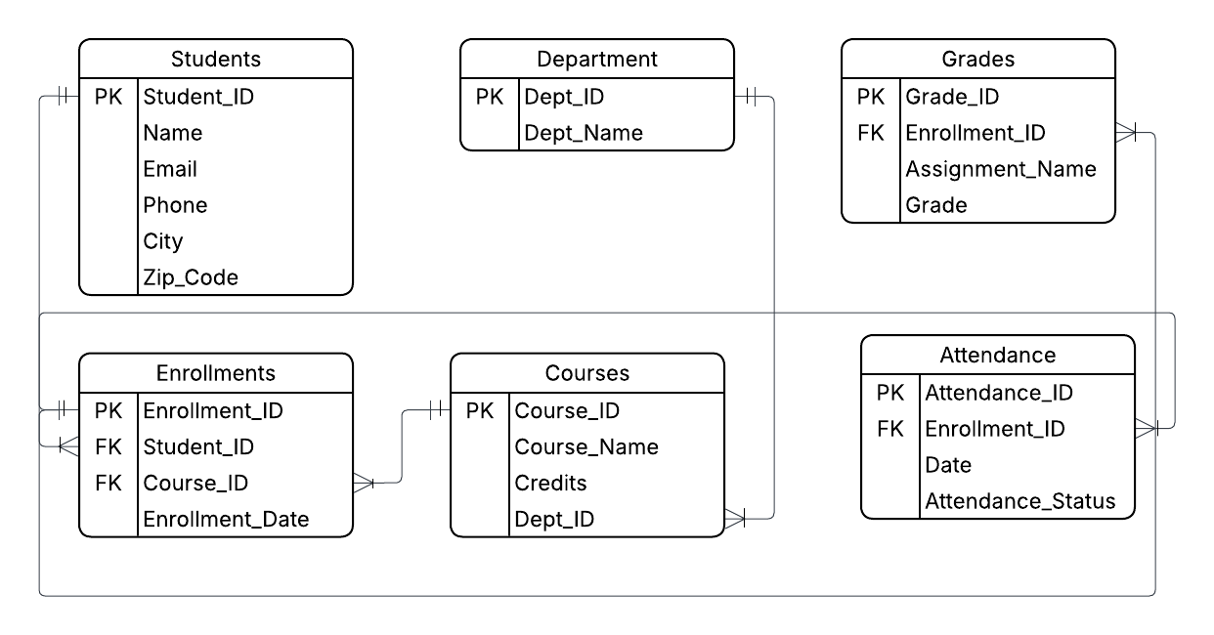
This is the final normalized model, incorporating all entities and their respective attributes.

5.2 Optimized Database Schema (SQL CREATE Statements)

Here is the refined, normalized database schema for your Student Information System (SIS). This version has been fully investigated and optimized to Third Normal Form (3NF) to ensure data integrity, remove redundancies, and follow your specific syntax requirements.

To view the optimized table structures and SQL CREATE statements, please double-click the file icon below:

Security Implementation

6.1 User Roles and Permissions

To ensure the system is secure and easy to manage, we have defined three distinct roles. Each role is designed around the specific tasks a person needs to perform in the school.
- Registrar: The primary owner of student records. They manage the "legal" side of the university, such as registering new students and creating official course lists.
- Instructor (Teacher): This role is focused on academic management. Instructors can manage the classes they teach, record grades, and track attendance for their students.
- Student: This is a restricted, read-only role. Students use the system primarily to check their own progress, such as viewing their grades or enrollment status.

6.2 Access Control Design
We used the "Principle of Least Privilege," meaning users only get the permissions they absolutely need to do their jobs. This prevents accidental data loss or unauthorized grade changes.
Table Name | Registrar | Instructor | Student
Students | SELECT, INSERT, UPDATE, DELETE | SELECT(View only) | SELECT (Personal info only)
Departments | SELECT, INSERT, UPDATE, DELETE | SELECT | SELECT
Courses | SELECT, INSERT, UPDATE, DELETE | SELECT | SELECT
Enrollments | SELECT, INSERT, UPDATE, DELETE | SELECT, INSERT | SELECT
Grades | SELECT (For Transcripts) | SELECT, INSERT, UPDATE, DELETE | SELECT (View only)
Attendance | SELECT (For Reports) | SELECT, INSERT, UPDATE, DELETE | SELECT (View only)

Key Design Logic:
- The Registrar's Power: Because the Registrar "owns" the student's legal status, they are the only ones who can add a new student or remove a course. They also manage Enrollments, meaning they are the ones who officially put a student into a class.
- The Instructor's Shield: Even though the Registrar has high authority, they cannot change a Grade. This ensures "Academic Integrity"—only the teacher who evaluated the student can decide the grade.
- Data Safety: By giving the Registrar DELETE permissions on the core tables (Students, Courses), we ensure that if a mistake is made during registration, it can be corrected by the head office.

Database Implementation

7.1 Chosen DBMS

For this project, we used MariaDB (or MySQL) as our Database Management System (DBMS).

We chose this system for the following reasons:
- Ease of Use: It is one of the most popular systems in the world, making it easy to find help and documentation.
- Performance: It is very fast at handling "Read" and "Write" tasks, which is perfect for a university system where many people check grades at the same time.
- Reliability: It supports "ACID" properties, which is a technical way of saying it ensures our student data is never lost or corrupted during a save.
- Standard SQL: It follows standard SQL rules, which allowed us to use the specific CREATE, ALTER, and CONSTRAINT commands required for our 3NF normalization.
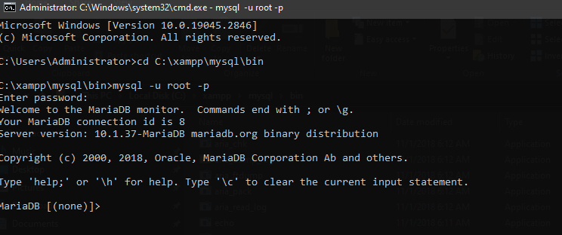

Data Population (DML)

To ensure the database was ready for testing, we populated each table with sample records. We have included 10 to 12 records per table to reflect a realistic university environment. This allows us to test complex queries, such as generating transcripts or checking attendance trends across different departments.

Population Strategy:
- Integrity First: Data was inserted following the "Parent-to-Child" order (Departments → Students → Courses → Enrollments → Grades/Attendance).
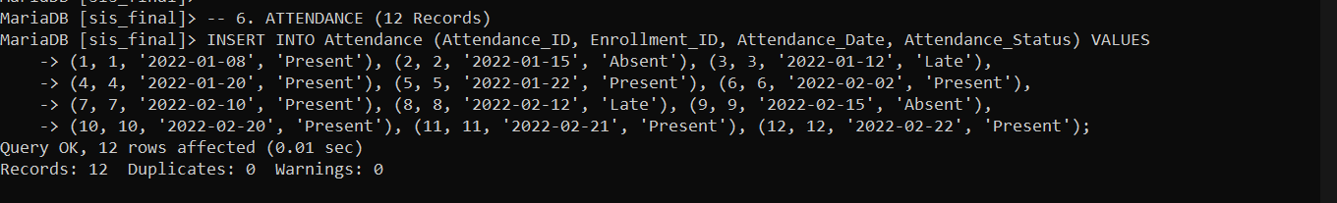
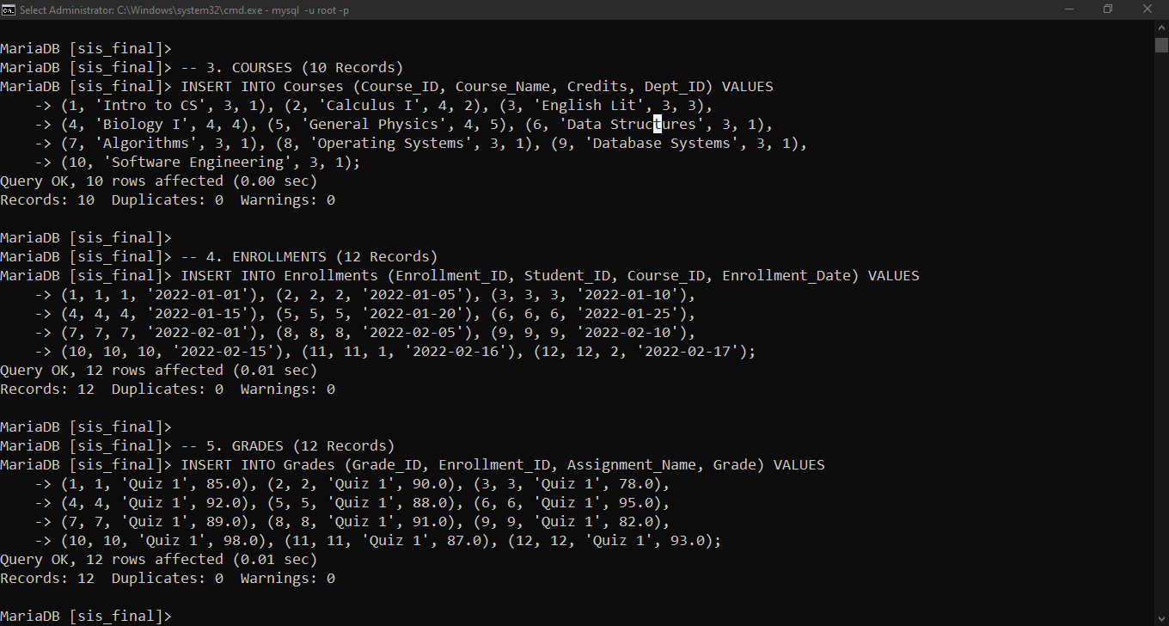
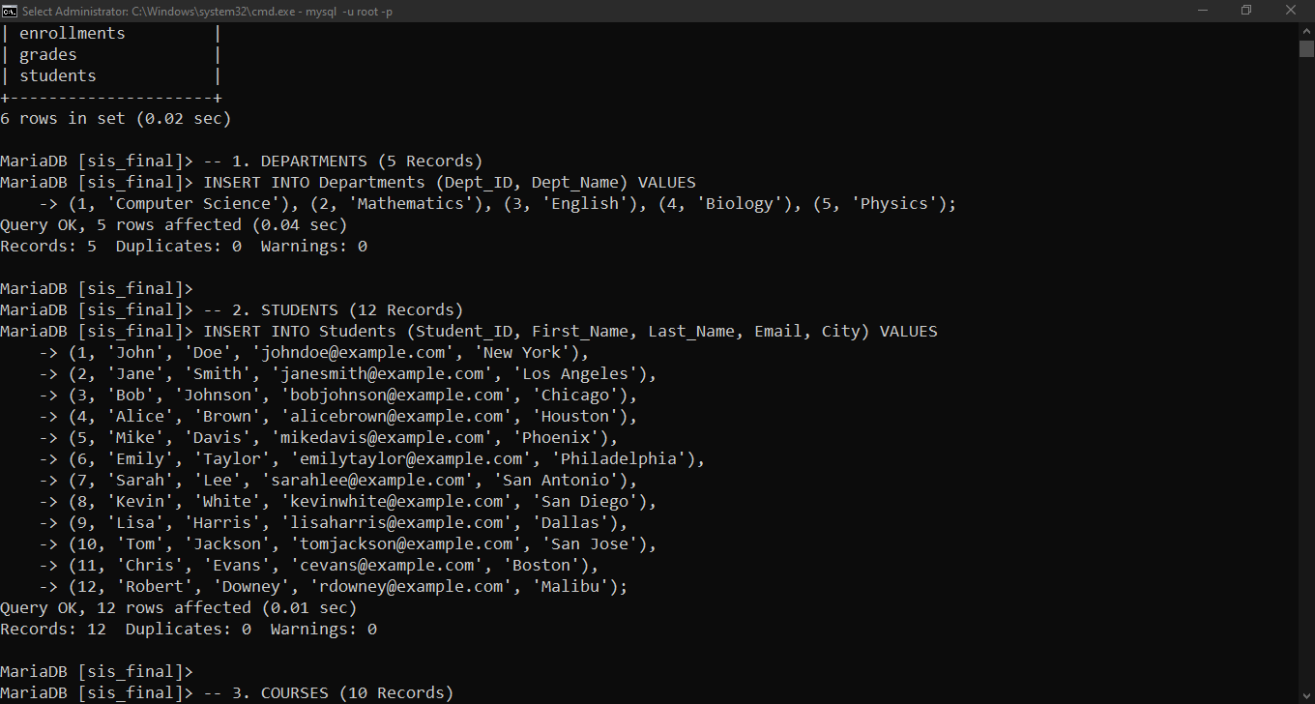
- Diversity: We included students from various cities and courses across five different departments to ensure our "Search" and "Filter" functions work correctly.

Functional and Performance Testing
8.1 Key SQL Queries Demonstration

Data Retrieval (SELECT with JOINs)

Example: Student Grade Report
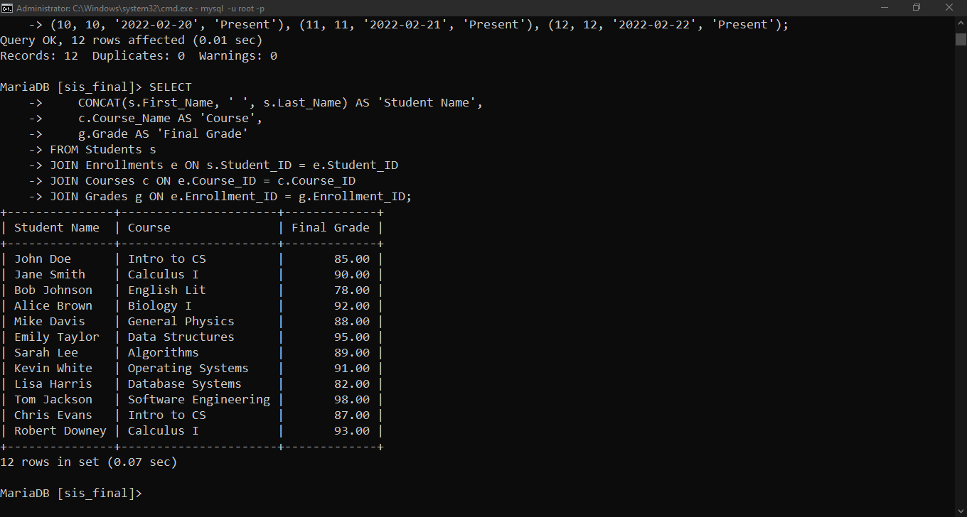
- This query retrieves the Full Name of the student, the Course Name, and the Grade they received.

Data Insertion and Updates

A key requirement for any university system is the ability to manage changing information. Because our database is in 3NF, these operations are "clean"—we only have to update data in one place to see the change everywhere.

1. Inserting a New Student Record

This example shows how the Registrar adds a new student to the system. Since we have separated the name and address fields, we ensure the data is captured correctly from the start.

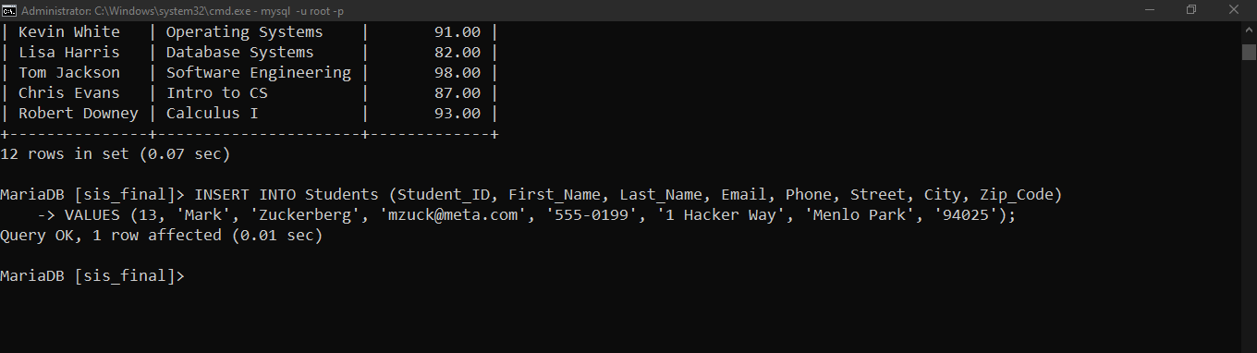

2. Updating an Existing Record

In the real world, students move houses often. In an unnormalized database, you might have to change the address in 10 different rows. In our optimized schema, you only update the Students table once.

Example: Updating John Doe’s address because he moved to a new apartment.
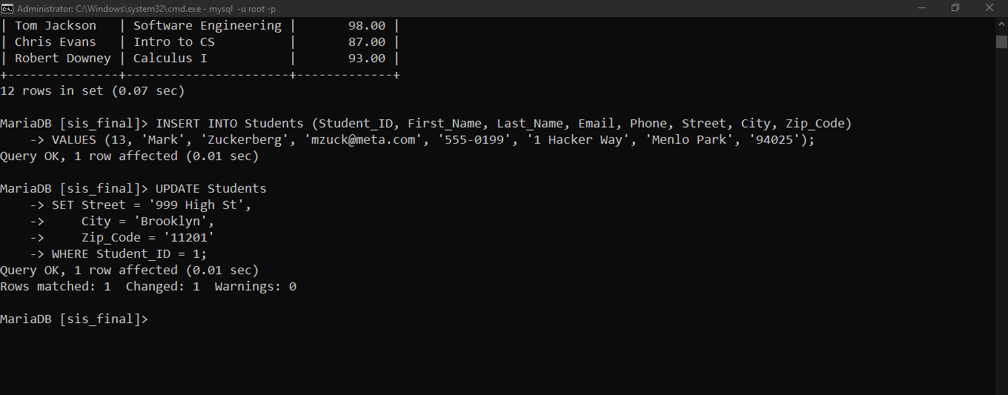

Aggregate Functions (COUNT, AVG, SUM)

Aggregate functions allow us to perform calculations on multiple rows of data to return a single value. This is essential for generating academic reports and tracking student performance.

1. Calculating Average Grade for a Course

This query calculates the average performance of all students enrolled in "Introduction to Computer Science" (Course_ID = 1). This helps the Registrar see if a course is too difficult or if the class is performing well.
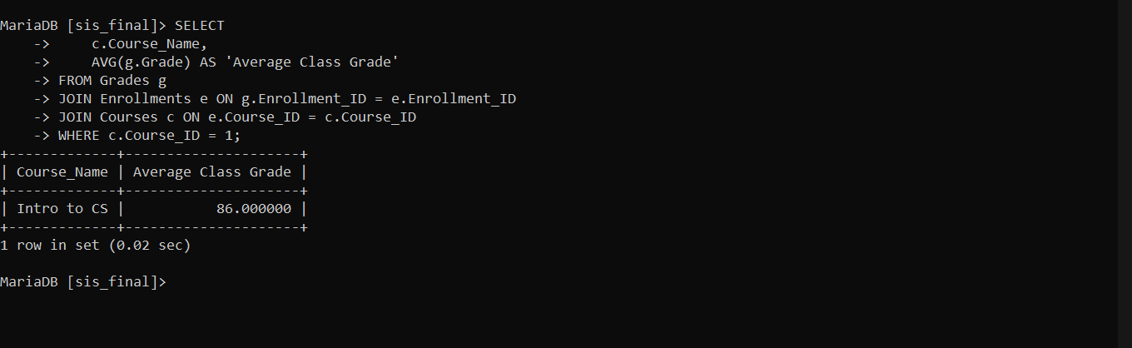

2. Counting Total "Present" Attendance

This query counts exactly how many times a specific student (Student_ID = 1) has been marked as "Present." This is vital for the Registrar when verifying if a student meets the requirements to pass a semester.
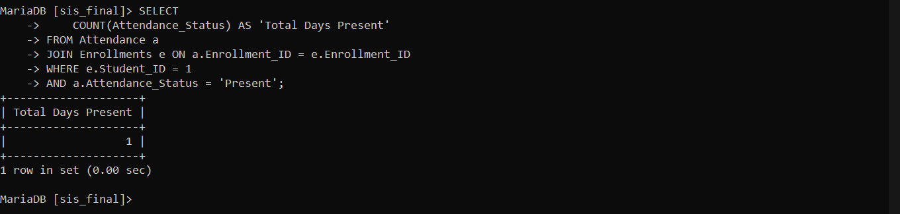

Security Testing

9.1 User Access Restrictions

To verify our security, we created a test account called student_test. This account represents a typical student who should only be able to view information, not change it.
- The Scenario: The student attempts to maliciously change their grade from an 85 to a 100.
- The Result: The MariaDB system immediately blocked the attempt.
- Proof of Security: As shown in the error message ERROR 1142 (Access Denied), our security permissions are working correctly. Even if a student gains access to the database terminal, they cannot alter academic records because the Registrar has not granted them UPDATE privileges.
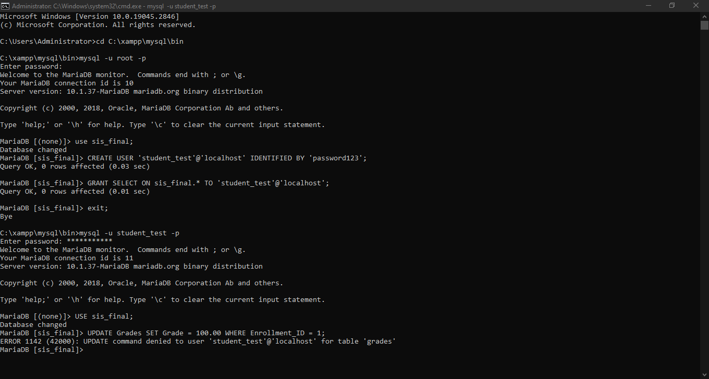

Conclusion

10.1 Summary of Findings

In the beginning, our database was "flat" and messy. It had several major design flaws, such as redundancy (repeating the same names over and over) and data anomalies (the risk of deleting a course and accidentally losing a student’s info).

By applying the normalization process, we broke the large table into smaller, logically connected tables. This ensures that:
- Every piece of information has its own home.
- The Registrar can update a student's address in one place, and it will be correct across the whole system.
- We eliminated the "junk" data that was taking up unnecessary space.

10.2 Performance Improvements

By optimizing the schema into 3NF, we have achieved several real-world benefits for the university:
- Faster Searches: Because the tables are smaller, the database doesn't have to scan through thousands of repeated rows to find one student.
- Storage Efficiency: We are no longer wasting space by storing the same course name or department name hundreds of times. This makes the database file much smaller.
- Data Integrity: With our Primary and Foreign Keys in place, the system is now "smart." It will not allow an Instructor to give a grade to a student who isn't even enrolled, or a Registrar to delete a student who still has active records.
- Security: As proven in our testing, we successfully separated the powers of the Registrar, Instructor, and Student. This keeps the university’s sensitive data safe from unauthorized changes.

Lessons Learned

Through the development and testing of the Student Information System, our group gained several key technical takeaways that are essential for real-world database management:
- The Necessity of Normalization (1NF to 3NF): We learned that creating a database is not just about storing information; it is about building relationships. By following the normalization process from 1NF to 3NF, we ensured that our data is "atomic" and organized. Without this, the database would suffer from redundancy, making it nearly impossible to maintain as the data grows.
- Integrity through the CRUD Process: We discovered that a database must perform reliably during every stage of the CRUD (Create, Read, Update, Delete) cycle. If the database is not designed correctly, simple updates can lead to errors. Ensuring that our DML (Data Manipulation Language) commands work accurately is the foundation of a high-performance system.
- Security as a Safeguard Against Anomalies: Perhaps the most crucial lesson was regarding data sensitivity. Since student records contain private information, we learned that managing User Access Control is not optional—it is a requirement. By restricting who can "Update" or "Delete," we protect the system from accidental data loss and malicious anomalies.
- Testing for Real-World Scenarios: We realized that while a database might work with 2 or 3 rows of data, real-world data is broad and complex. Testing with multiple records and complex JOIN queries showed us the importance of Performance Optimization. A good database must not only be correct; it must be fast and efficient under pressure.

